TCS NQT QUESTIONS

TABLE OF CONTENTS

Easy

Numerical Ability | 25
Reasoning Ability | 23
Verbal Ability | 2
Basic-Medium
Numerical Ability | 27
Reasoning Ability | 6
Verbal Ability  Medium | 17
Numerical Ability | 8
Reasoning Ability | 7
Verbal Ability | 35

Numerical Ability
Question 1
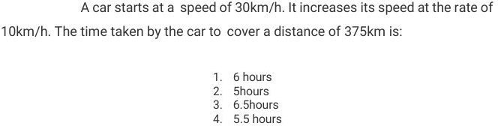

Question 2
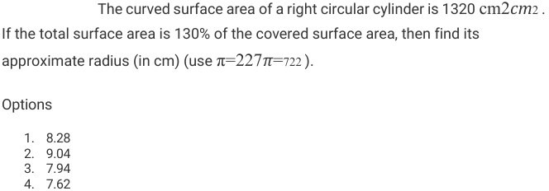

Question 3
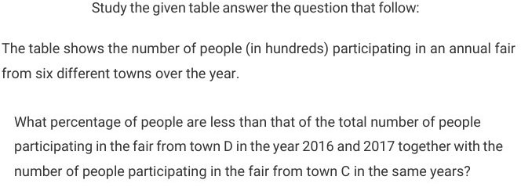

Numerical Ability
Question 4
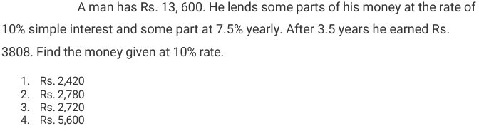
Question 5
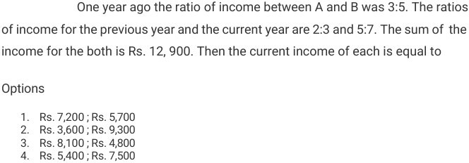

Question 6
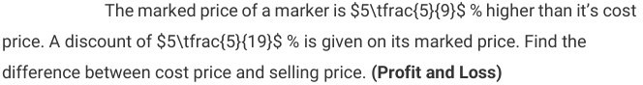

Question 7
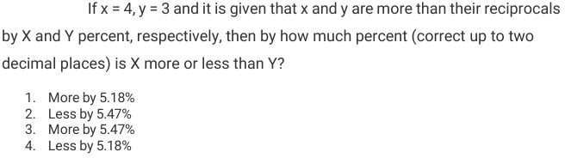

Numerical Ability
Question 8
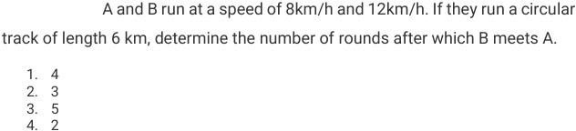

Question 9
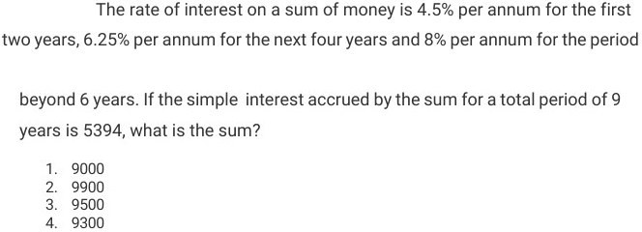

Question 10
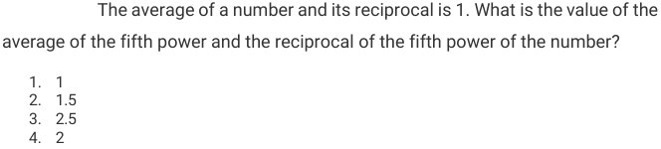

Numerical Ability
Question 11
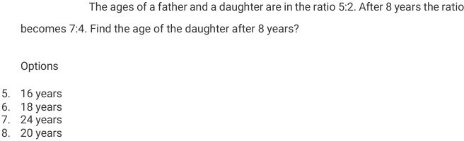

Question 12
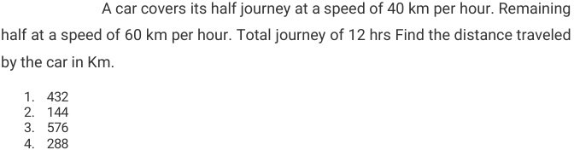

Question 13
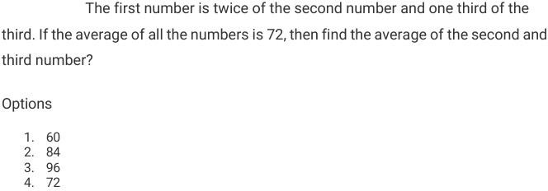

Numerical Ability
Question 14
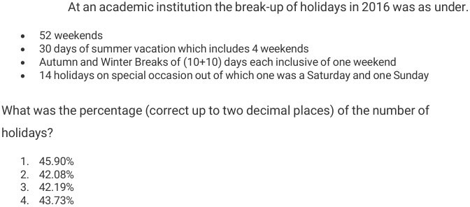

Question 15
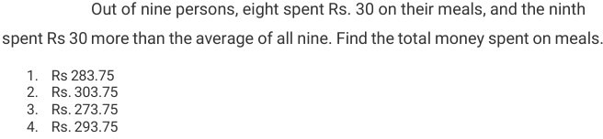
Question 16
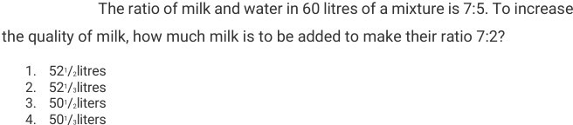

Numerical Ability
Question 17
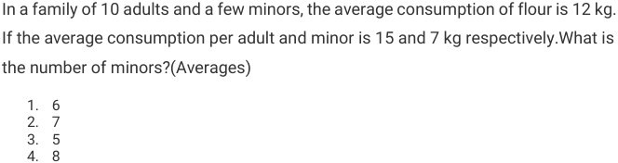

Question 18
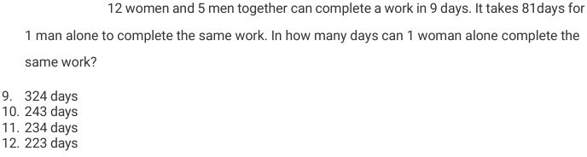
Question 19
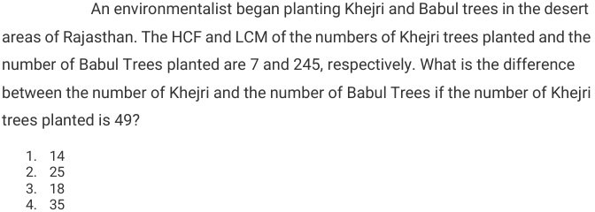

Numerical Ability
Question 20
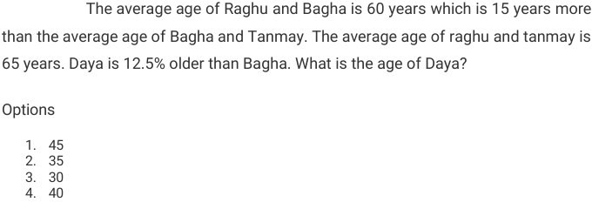

Question 21
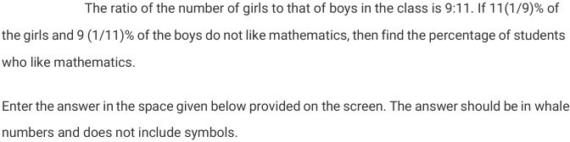

Question 22
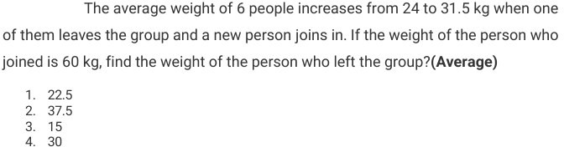

Numerical Ability
Question 23
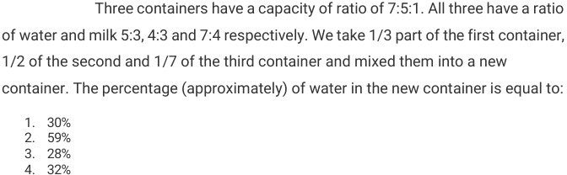

Question 24
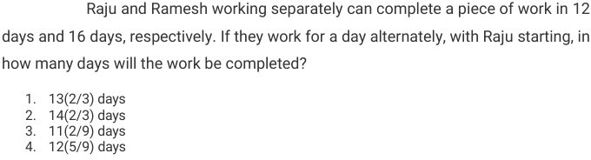
Question 25
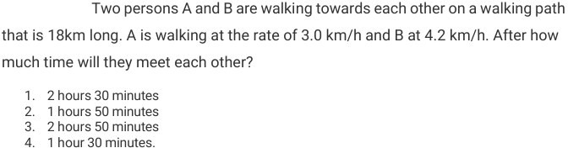

Reasoning Ability

Reasoning Ability
Question 26
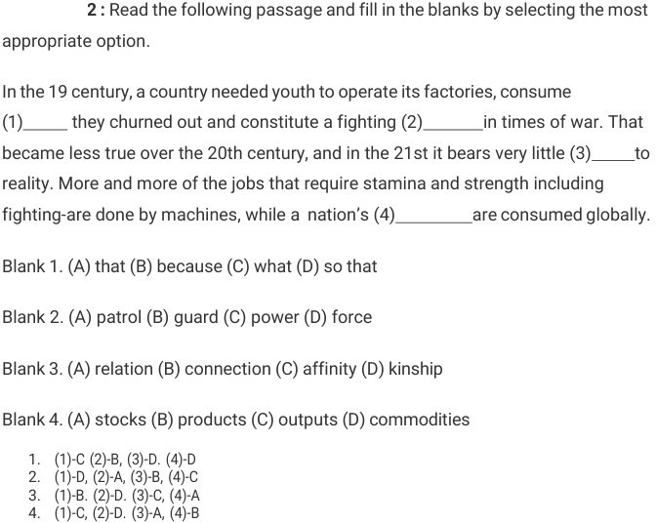

Question 27


Reasoning Ability
Question 28
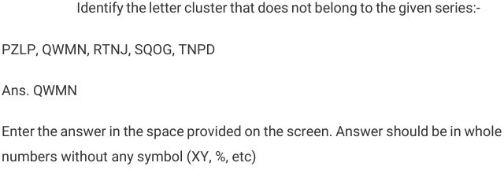
Question 29
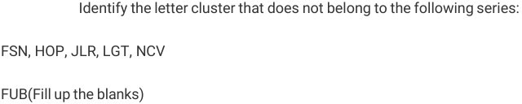

Reasoning Ability
Question 30

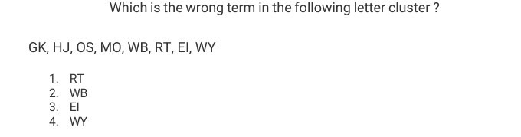
Question 31
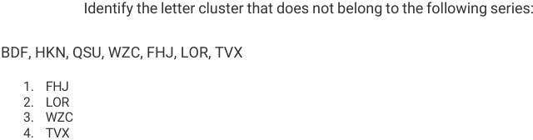

Reasoning Ability
Question 32

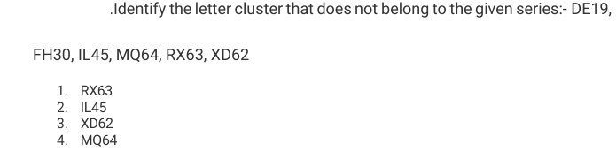
Question 33
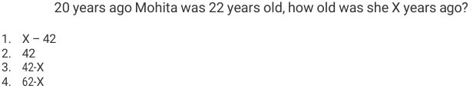
Question 34
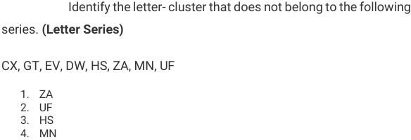

Reasoning Ability
Question 35
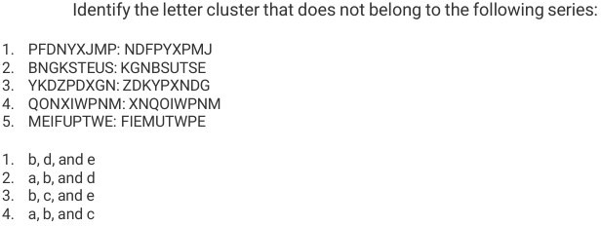
Question 36
The average of a number and its reciprocal is 1 . What is the value of the average of the fifth power and the reciprocal of the fifth power of the number?
- 1
- 1.5
- 2.5
- 2

Reasoning Ability
Question 37
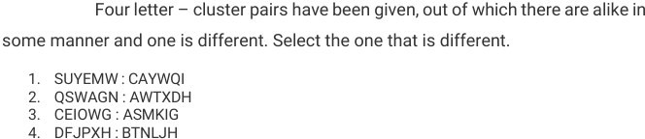

Question 38
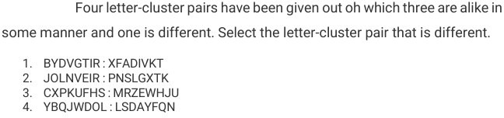
Question 39
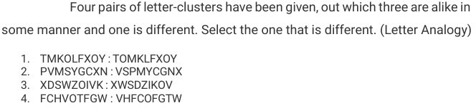

Reasoning Ability
Question 40
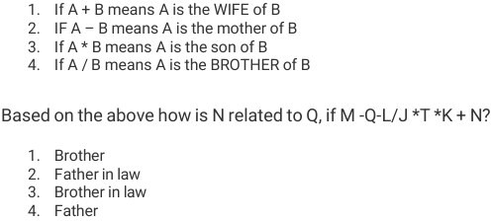

Question 41
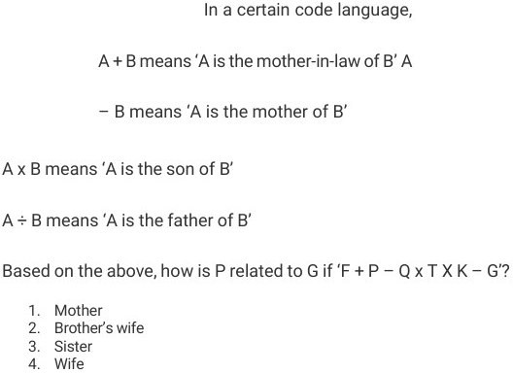

Reasoning Ability
Question 42
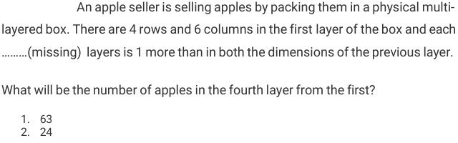
- 48
- 35

Question 43
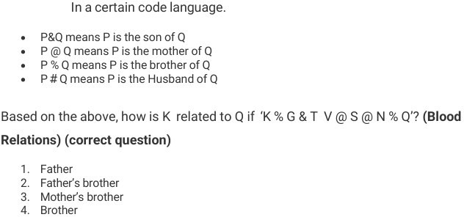

Reasoning Ability
Question 44
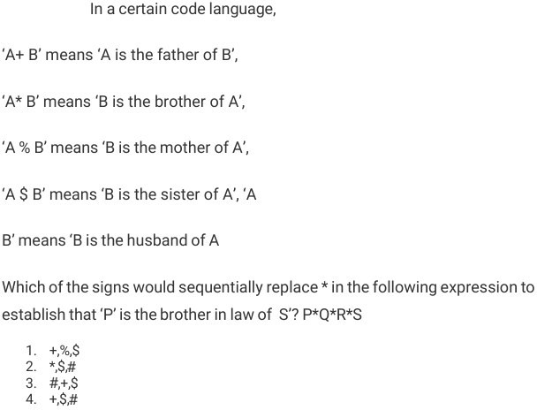
Question 45
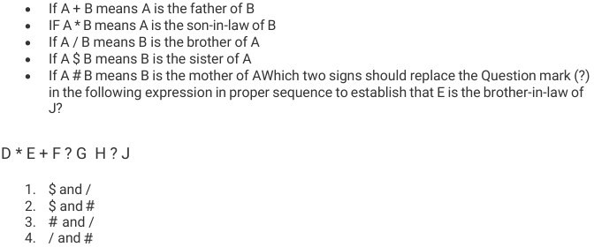

Reasoning Ability
Question 46
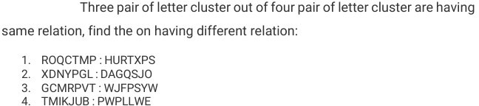

Question 47
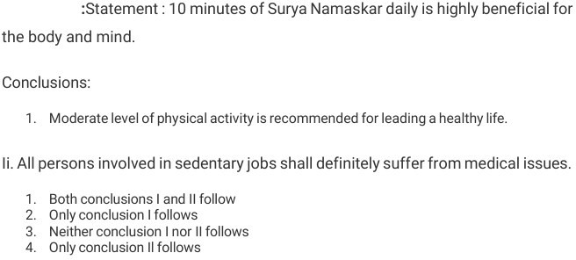
Question 48
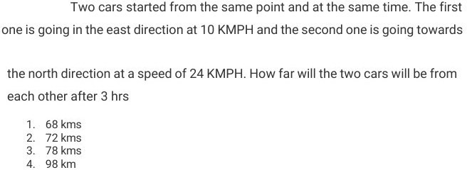

Verbal Ability
Question 49
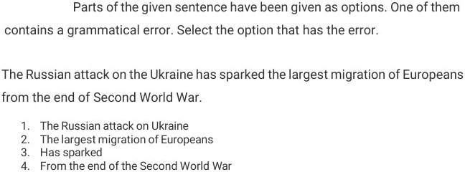

Question 50
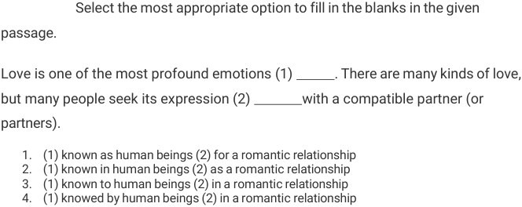

Numerical Ability
Question 51
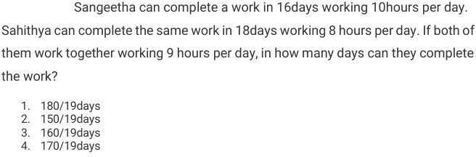
Question 52
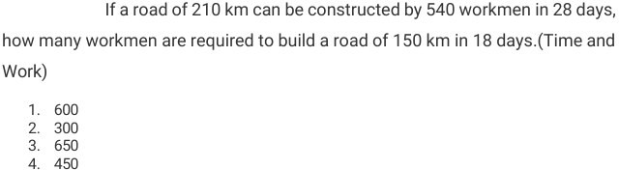

Question 53
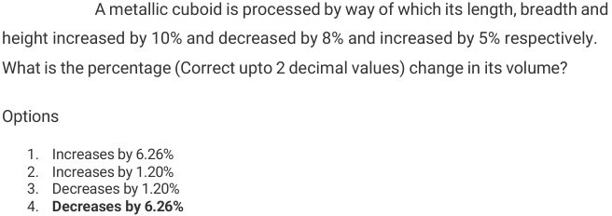

Numerical Ability
Question 54
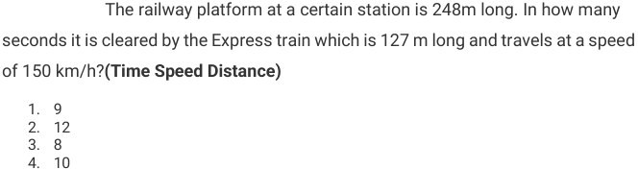

Question 55
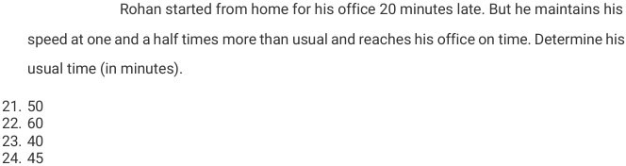

Question 56
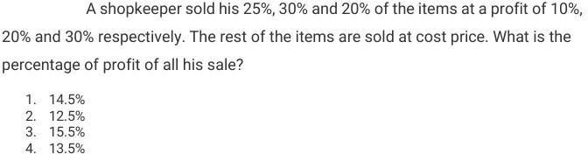

Numerical Ability
Question 57
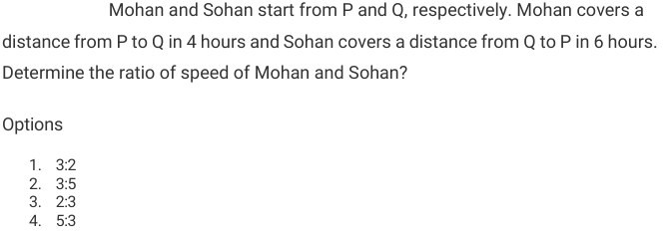

Question 58
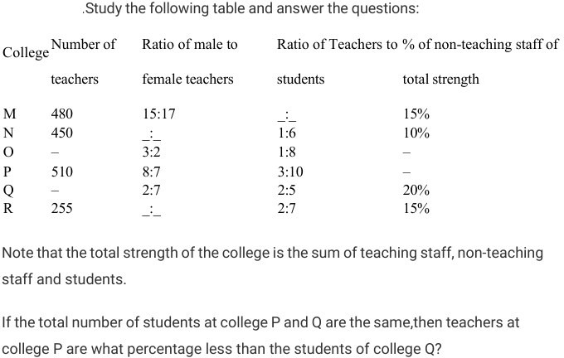

Numerical Ability
Question 59
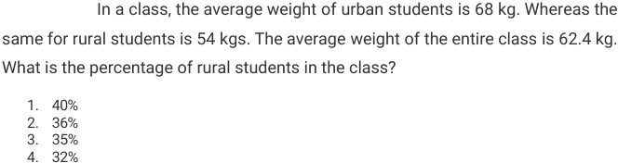

Question 60
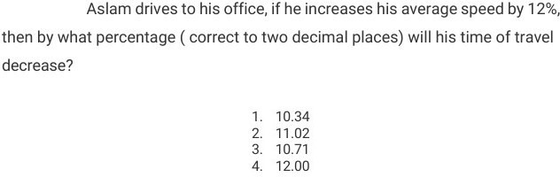
Question 61
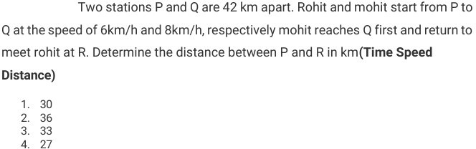

Numerical Ability
Question 62
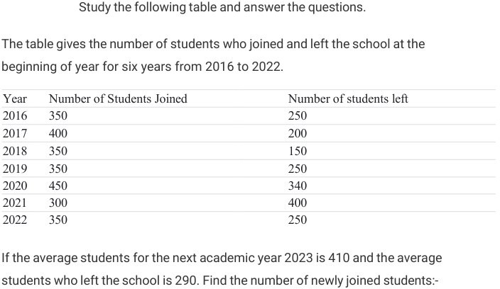

Question 63
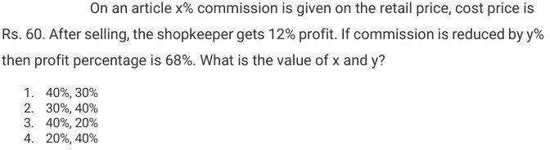
Question 64
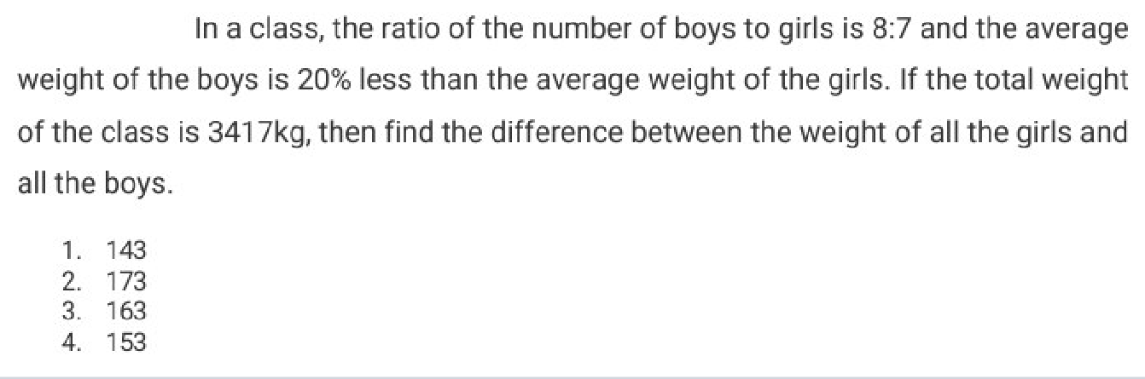

Numerical Ability
Question 65
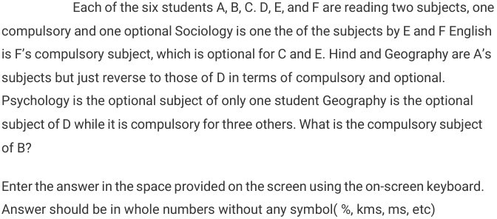

Question 66
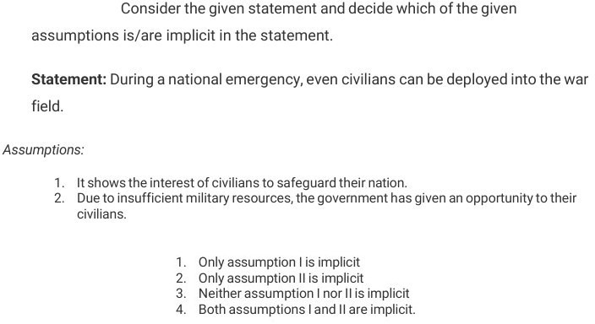

Numerical Ability
Question 67
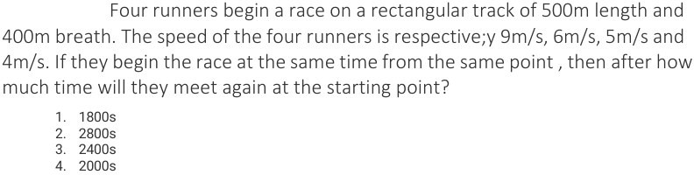
Question 68
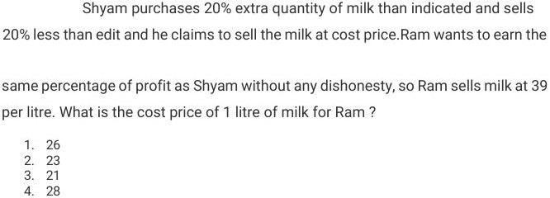

Question 69

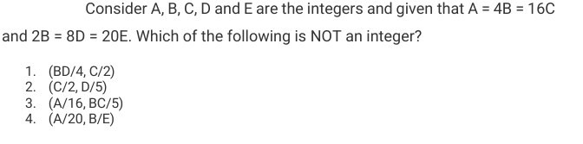

Numerical Ability
Question 70
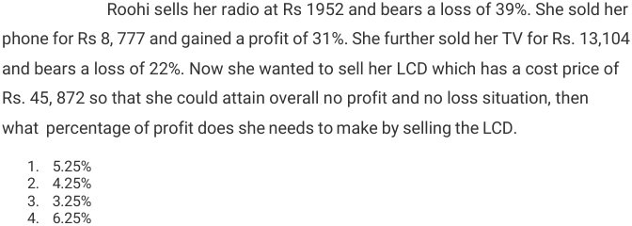

Numerical Ability
Question 71

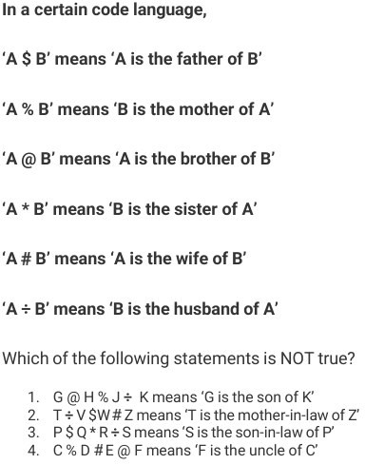

Numerical Ability
Question 72
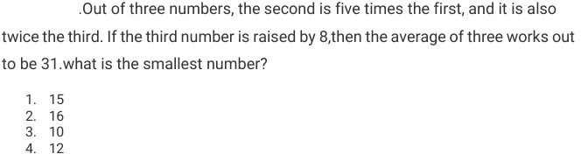

Question 73
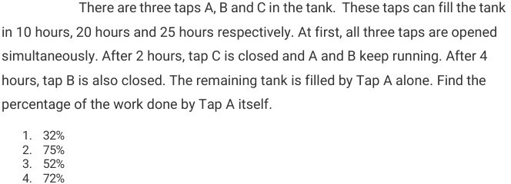

Question 74
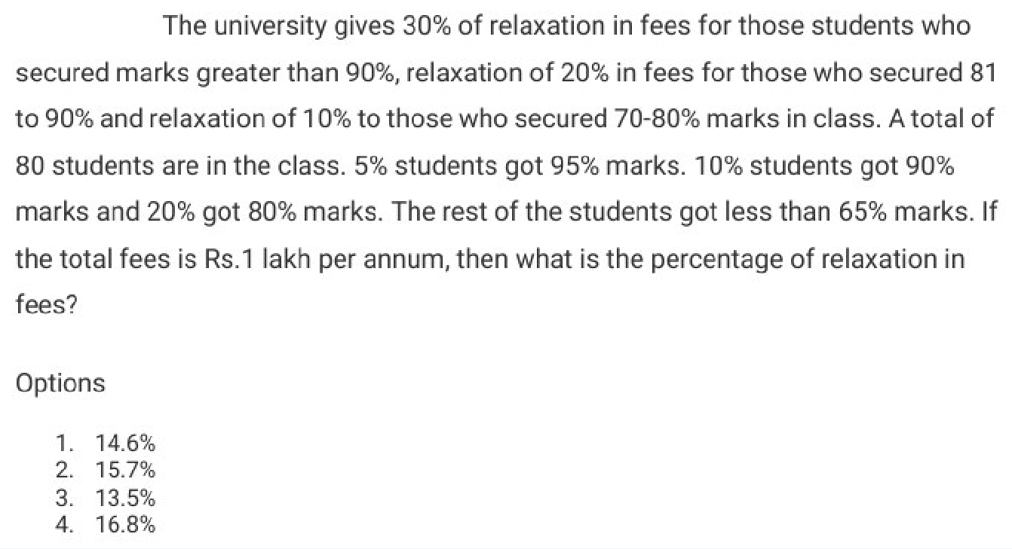

Numerical Ability
Question 75
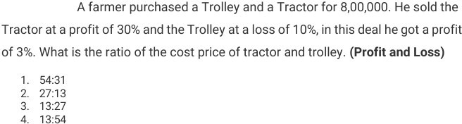

Question 76
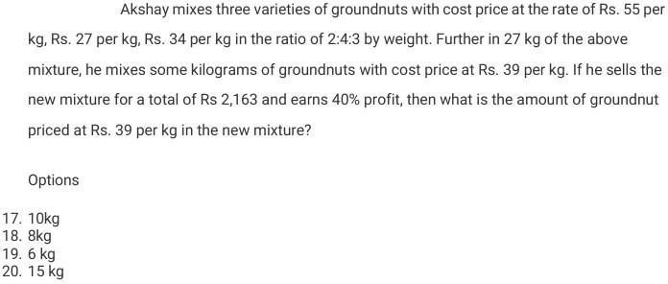

Numerical Ability
Question 77
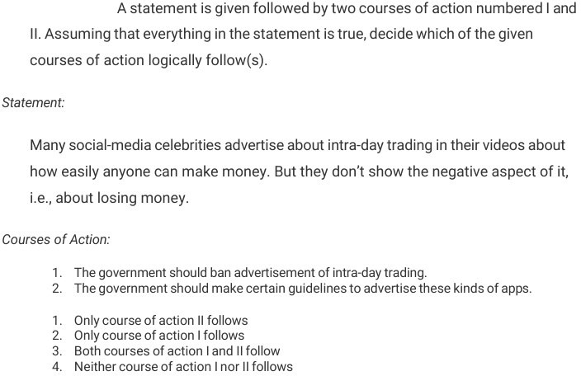

Reasoning Ability

Reasoning Ability
Question 78

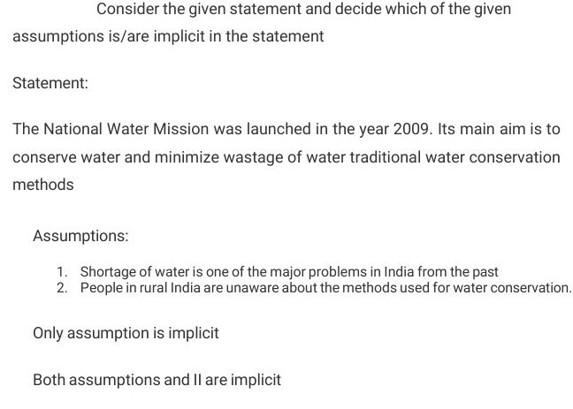

Reasoning Ability
Question 79

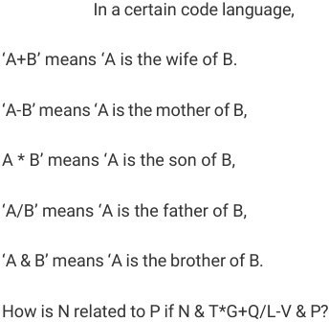
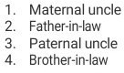

Reasoning Ability
Question 80
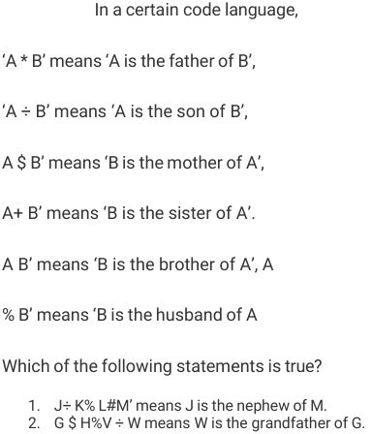
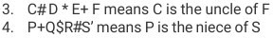

Reasoning Ability
Question 81
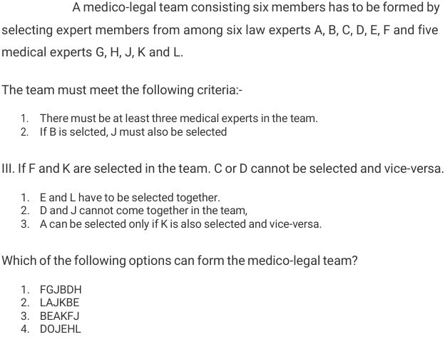

Reasoning Ability
Question 82
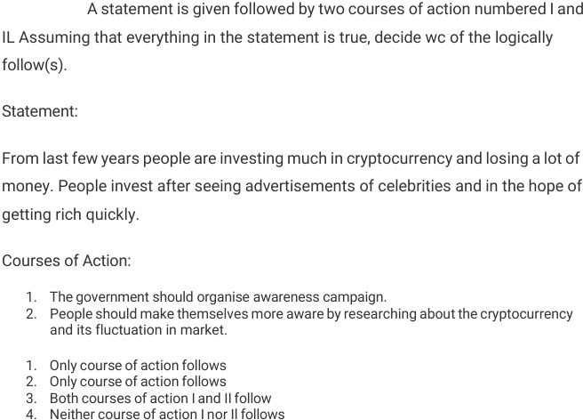

Reasoning Ability
Question 83
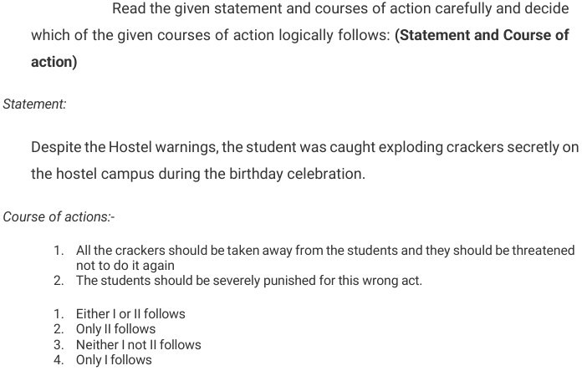

Verbal Ability
Question 84
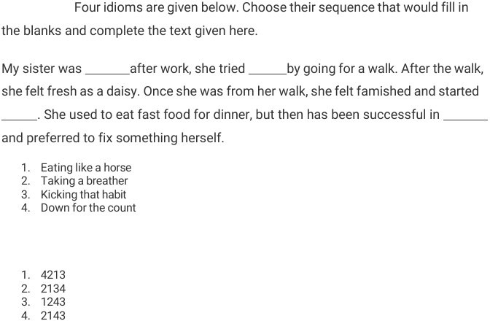

Question 85
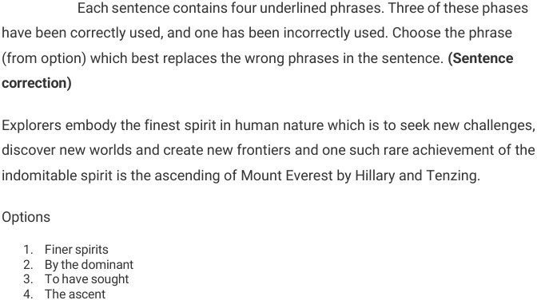

Verbal Ability
Question 86
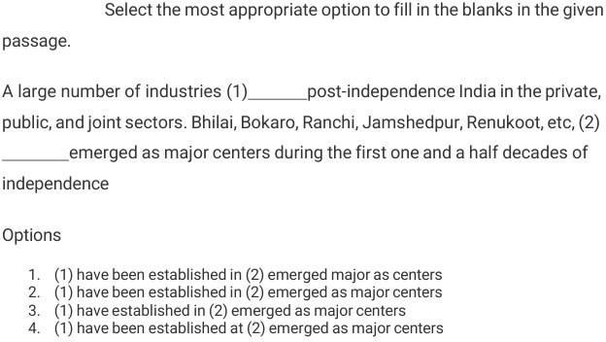

Verbal Ability
Question 87
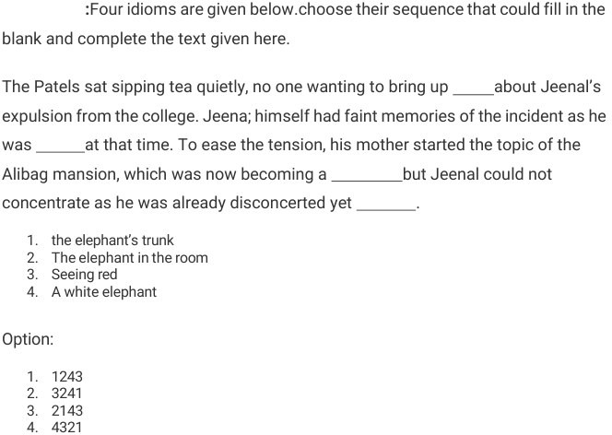

Question 88
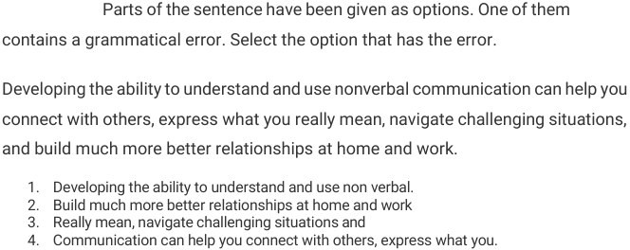

Verbal Ability
Question 89
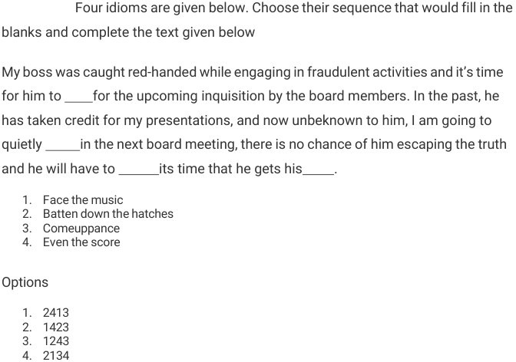

Verbal Ability
Question 90
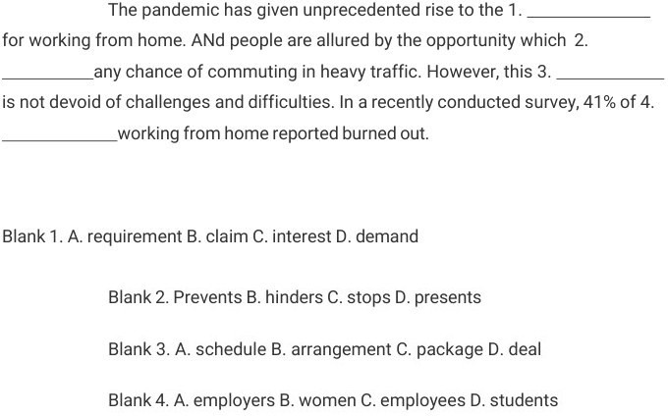
Question 91
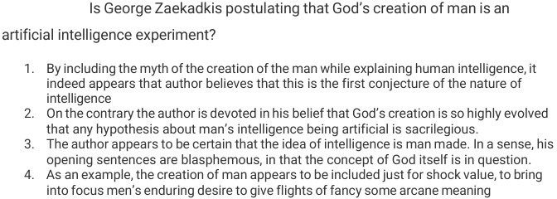

Verbal Ability
Question 92
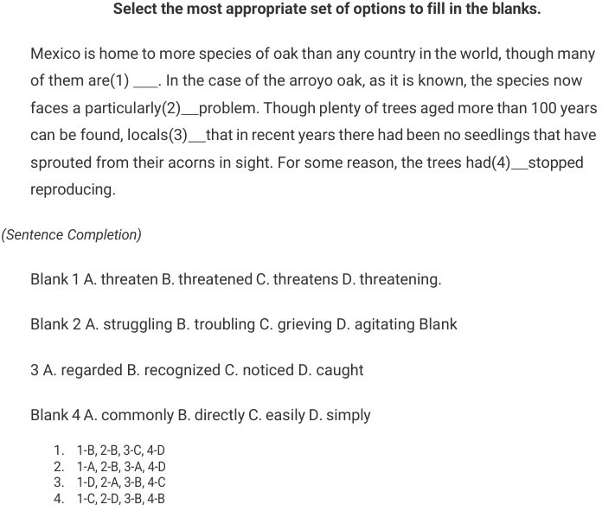

Verbal Ability
Question 93

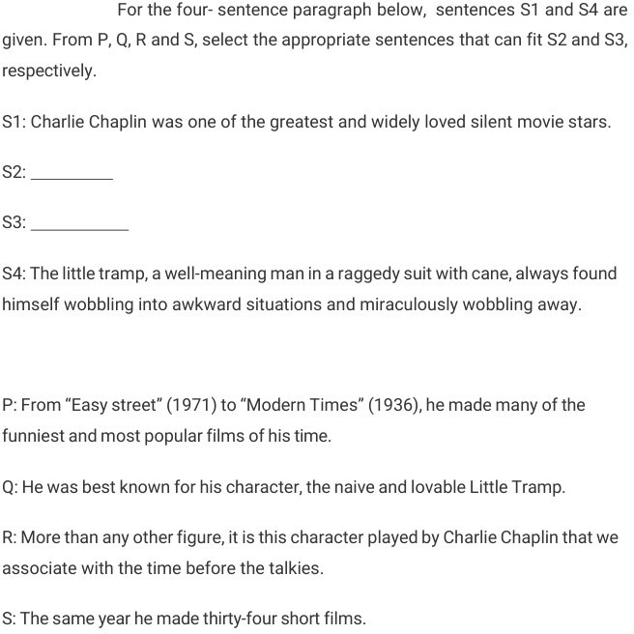

Verbal Ability
Question 94
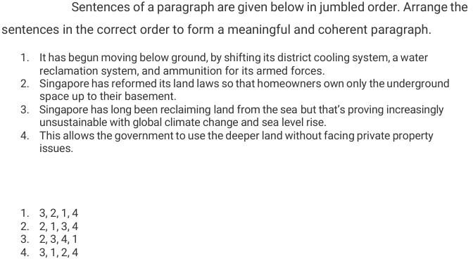

Question 95
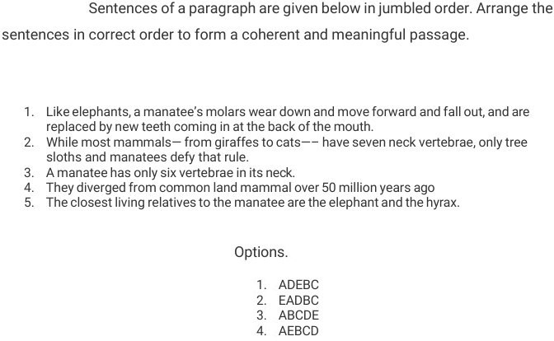

Verbal Ability
Question 96
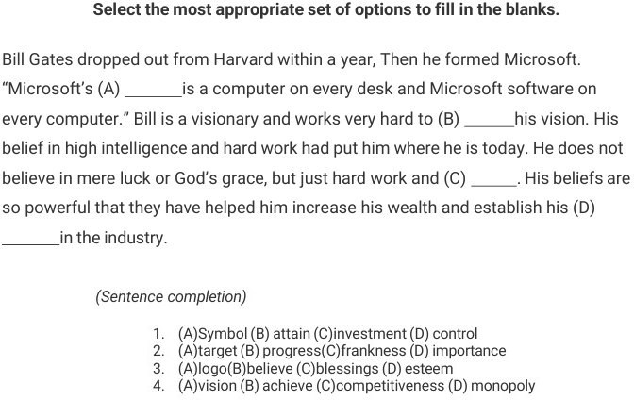

Verbal Ability
Question 97
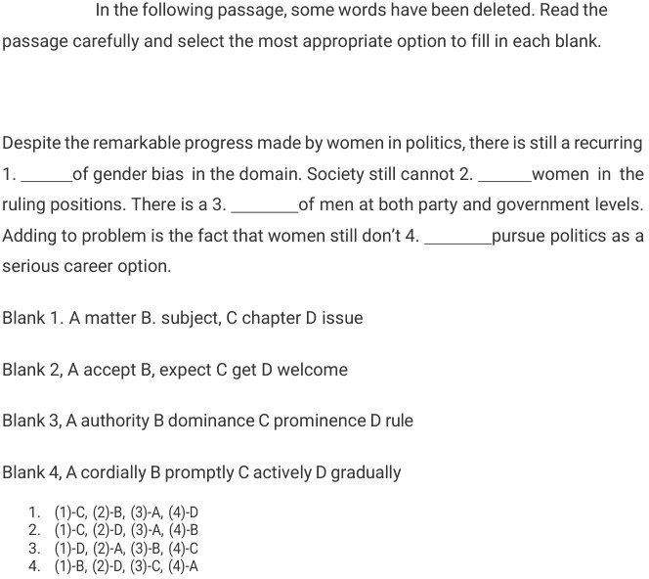

Verbal Ability
Question 98
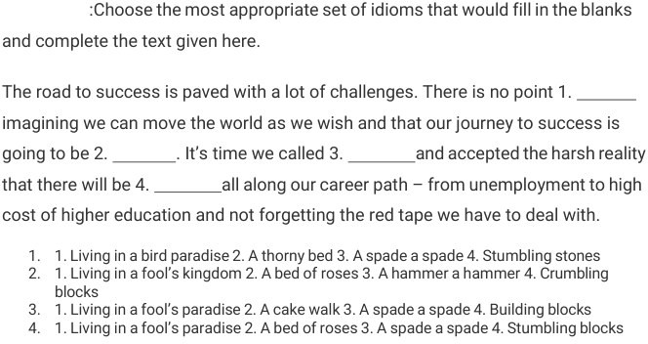
Question 99
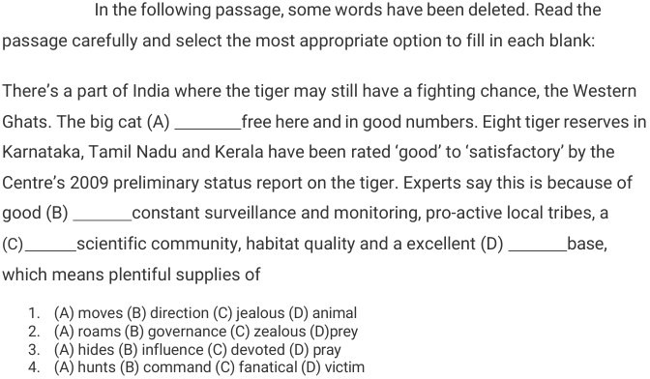

Verbal Ability
Question 100
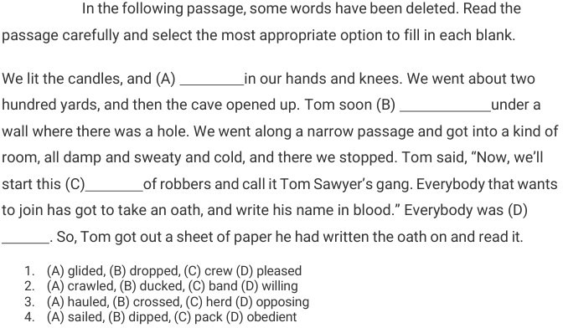

Numerical Ability
Question 101
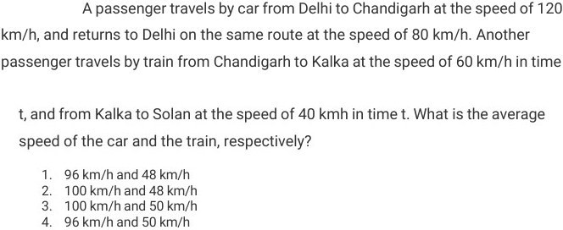

Question 102
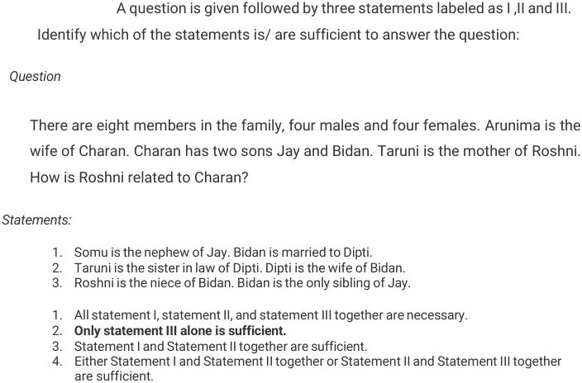

Numerical Ability
Question 103

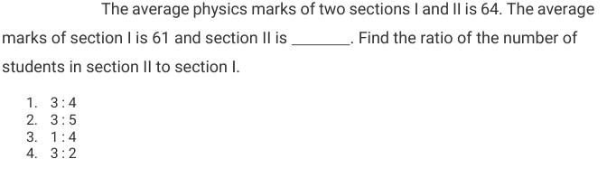

Numerical Ability
Question 104
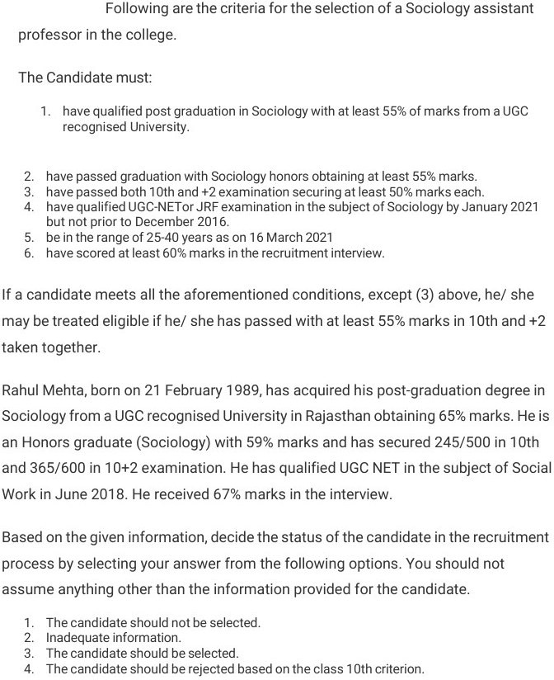

Numerical Ability
Question 105
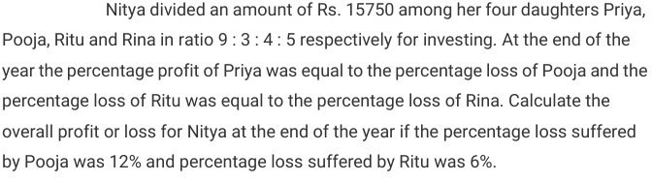
1.Profit of RS.165
2.Loss of RS.165
3.Loss of RS.135
4.Profit of RS.135

Numerical Ability
Question 106
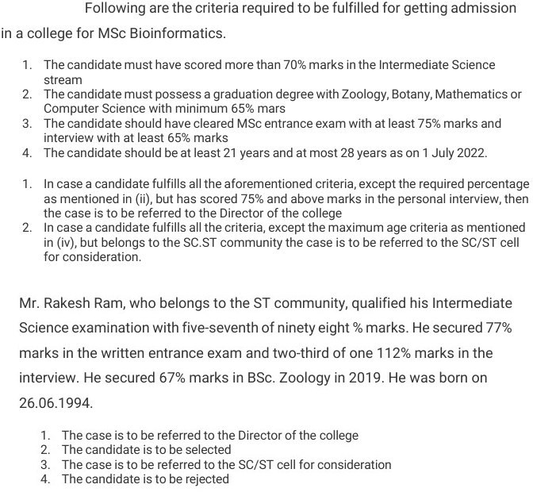

Numerical Ability
Question 107
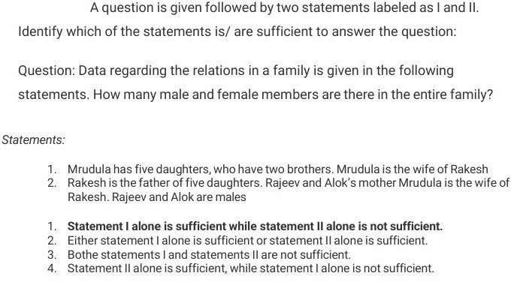

Numerical Ability
Question 108

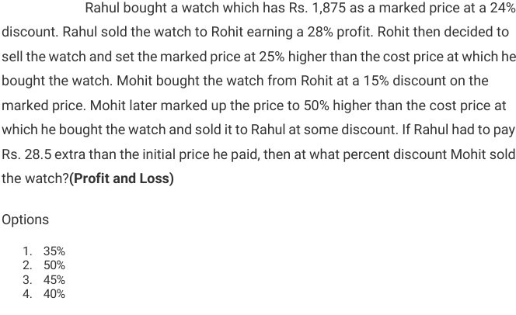

Reasoning Ability
Question 109
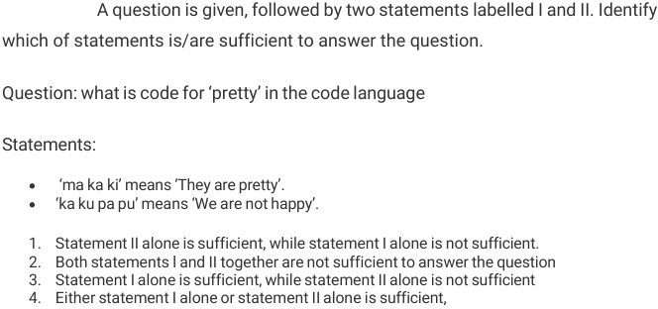

Question 110
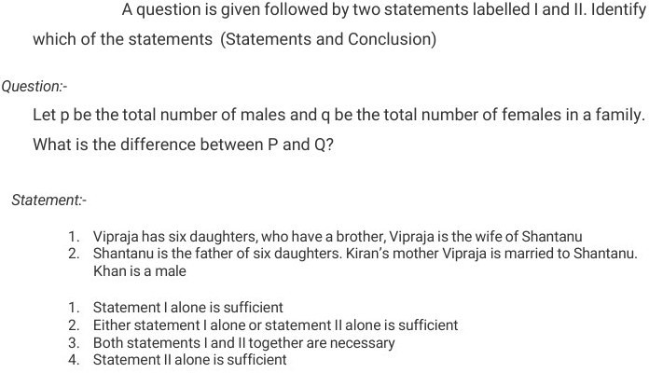

Reasoning Ability
Question 111
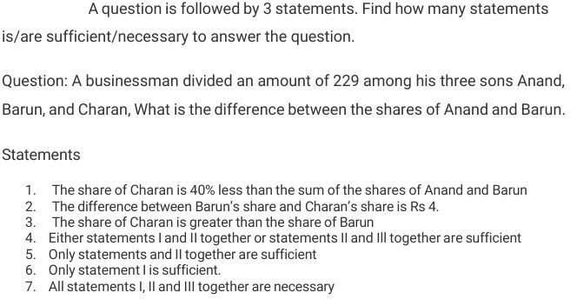

Reasoning Ability
Question 112
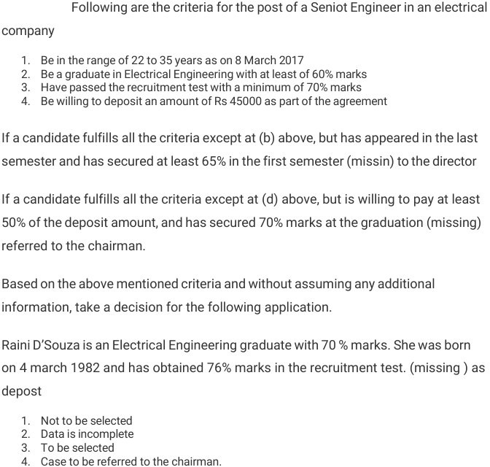

Reasoning Ability
Question 113
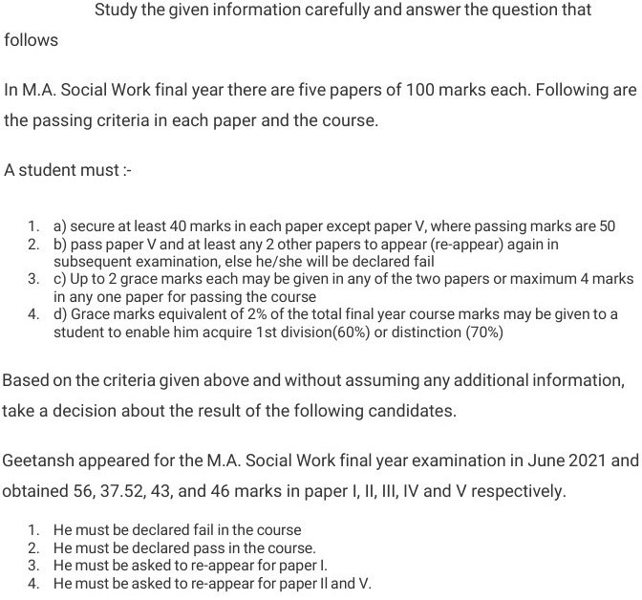

Reasoning Ability
Question 114
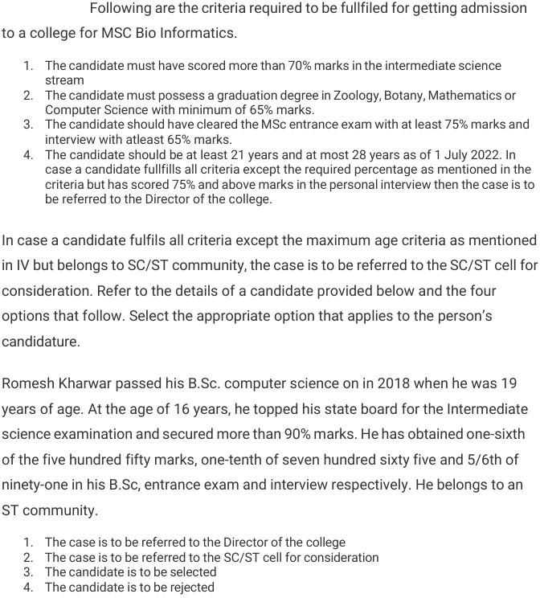

Reasoning Ability
Question 115
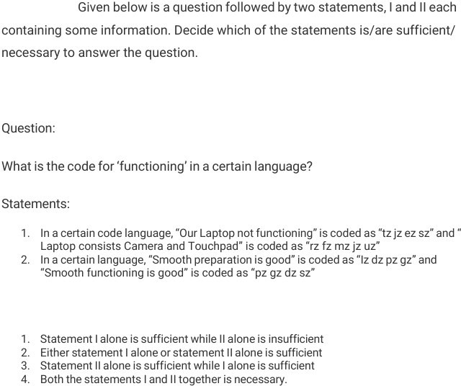

Verbal Ability

Verbal Ability
Question 116

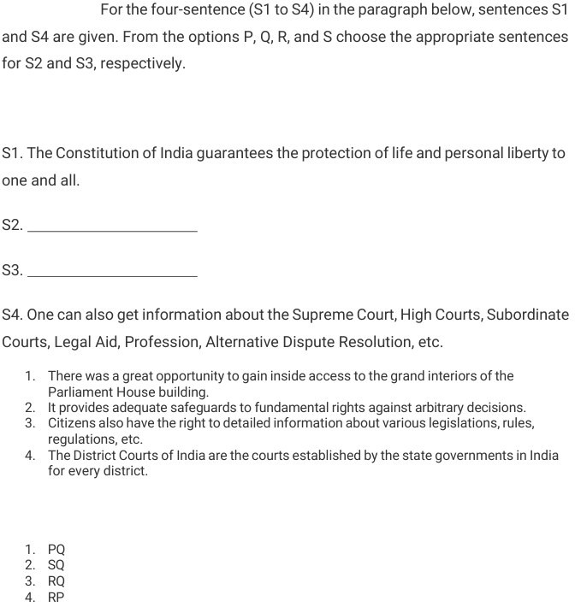

Verbal Ability
Question 117
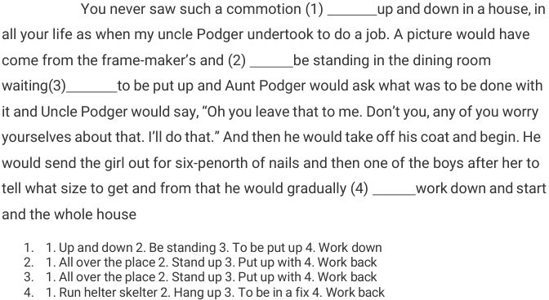

Question 118
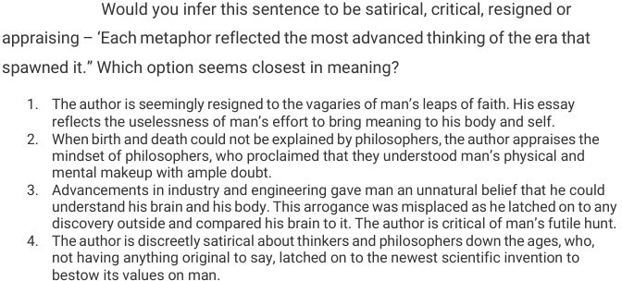

Verbal Ability
Question 119
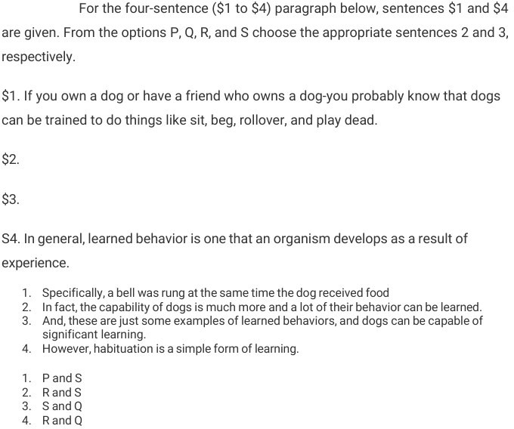

Verbal Ability
Question 120
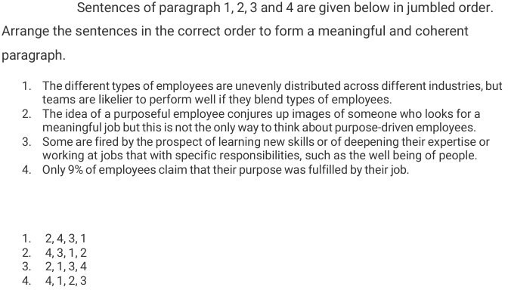

Verbal Ability
Question 121
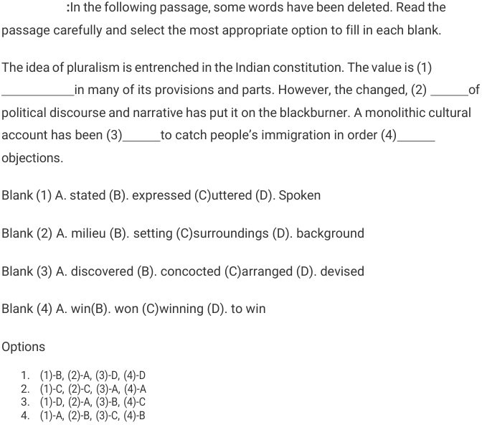

Verbal Ability
Question 122
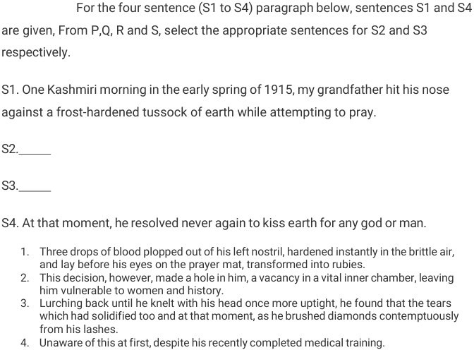

Question 123
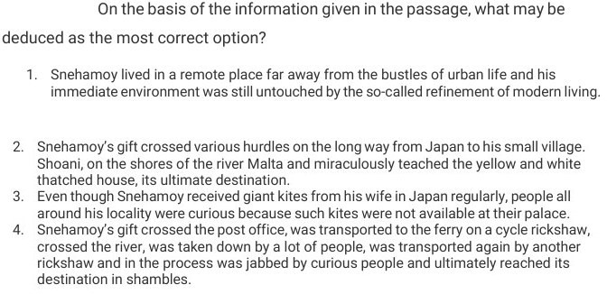

Verbal Ability
Question 124
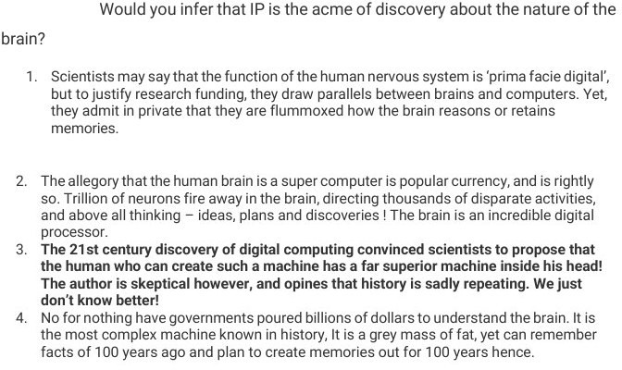
Question 125
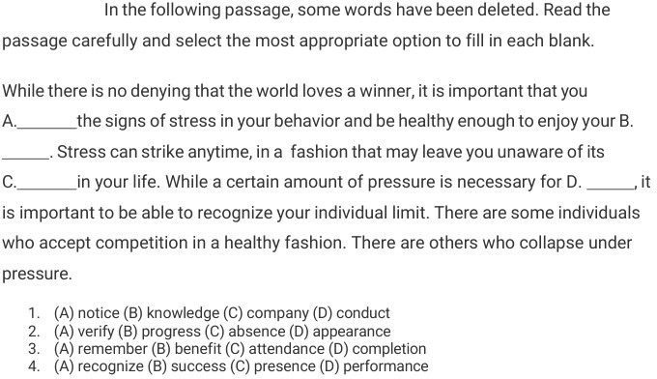

Verbal Ability
Question 126
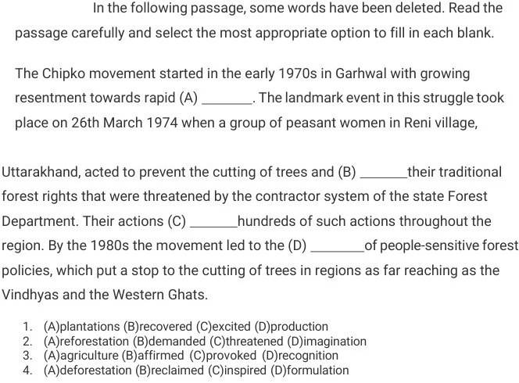

Verbal Ability
Question 127
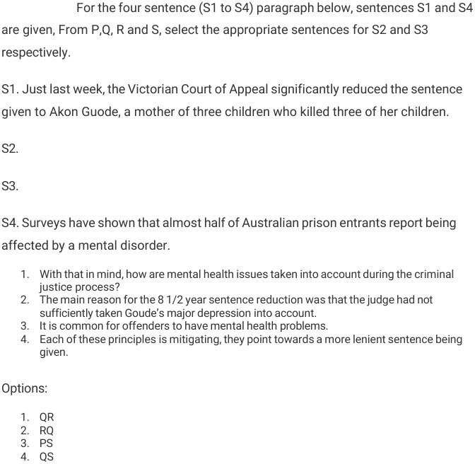

Verbal Ability
Question 128
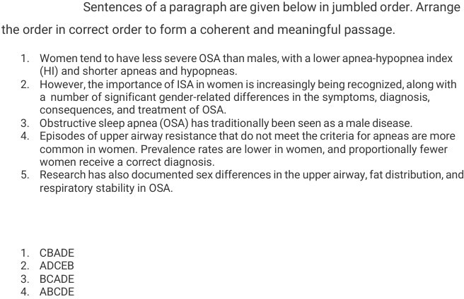
Question 129
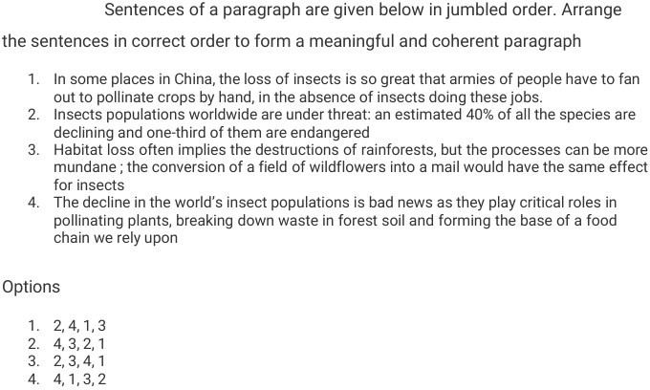

Verbal Ability
Question 130
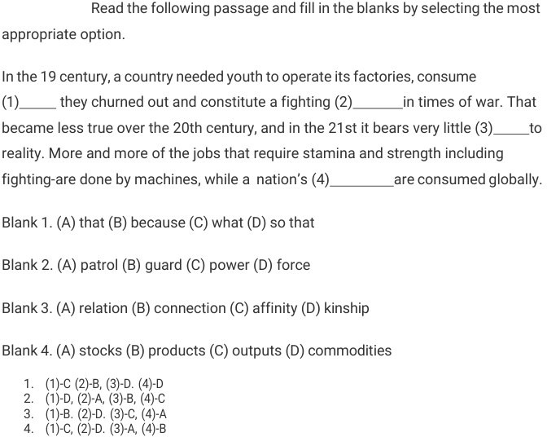

Verbal Ability
Question 131
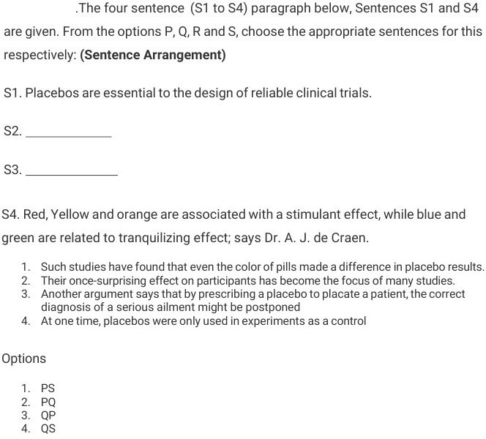

Verbal Ability
Question 132
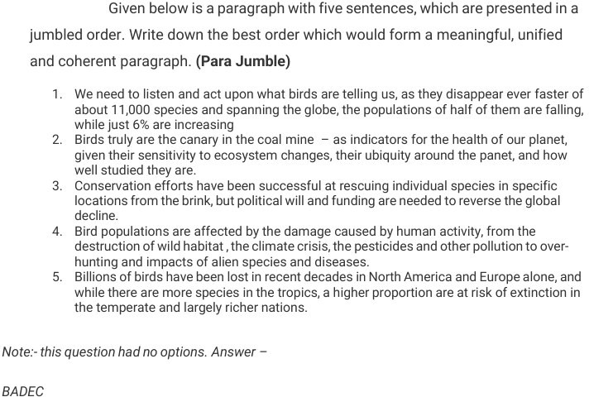

Question 133
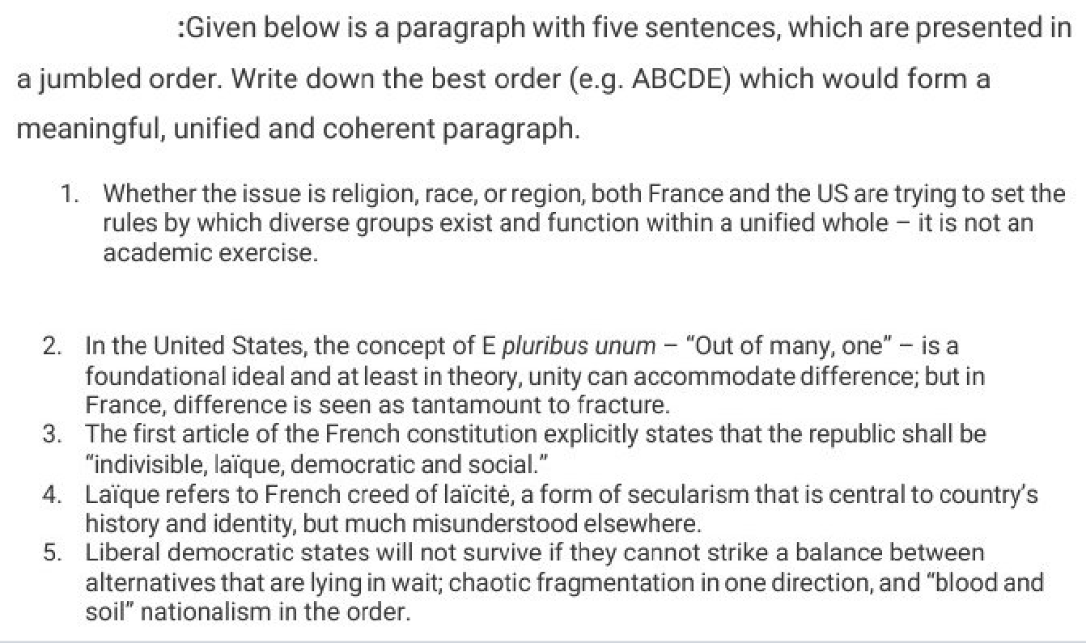

Verbal Ability
Question 134
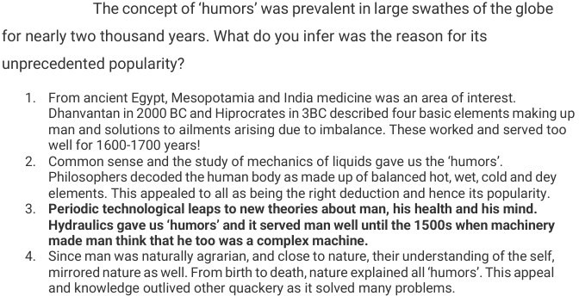

Verbal Ability
Question 135

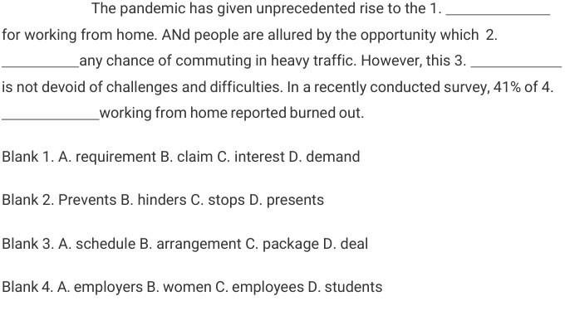

Verbal Ability
Question 136
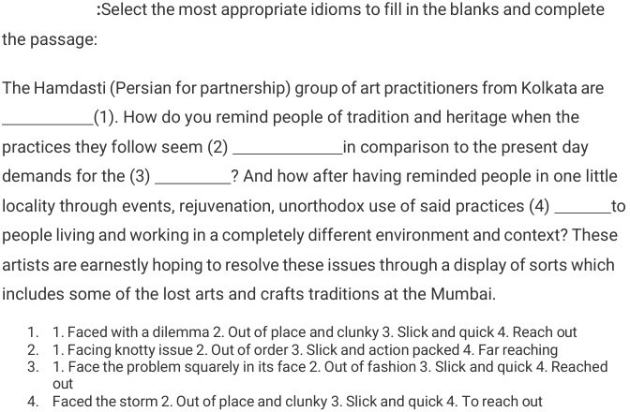

Verbal Ability
Question 137
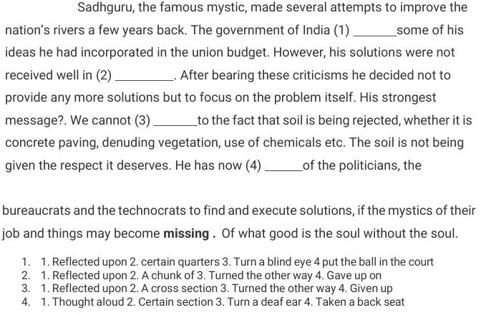
Question 138
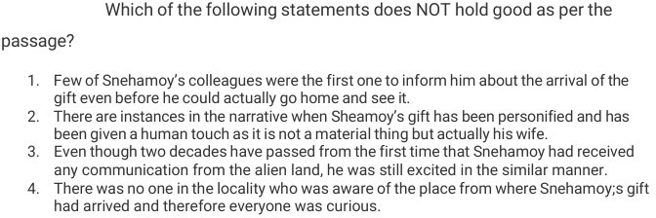

Verbal Ability
Question 139
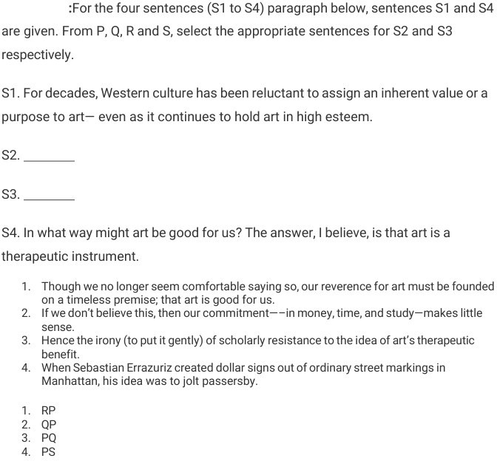

Verbal Ability
Question 140
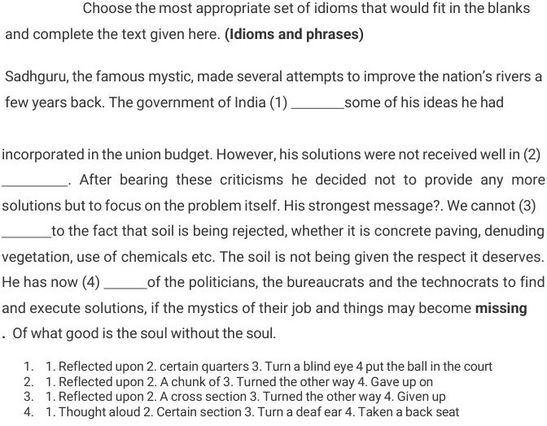

Verbal Ability
Question 141
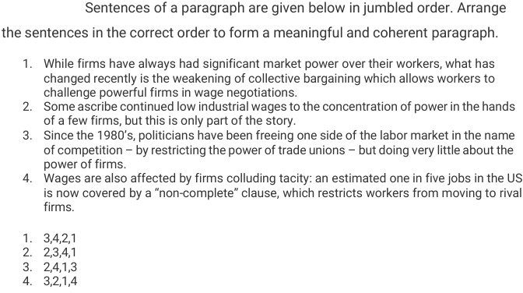
Question 142
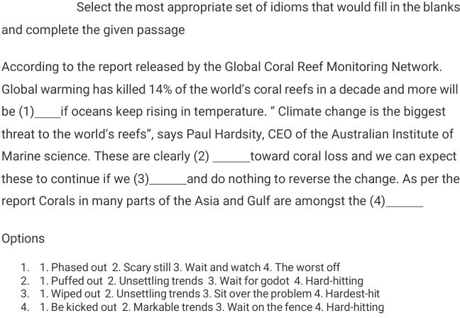

Verbal Ability
Question 143
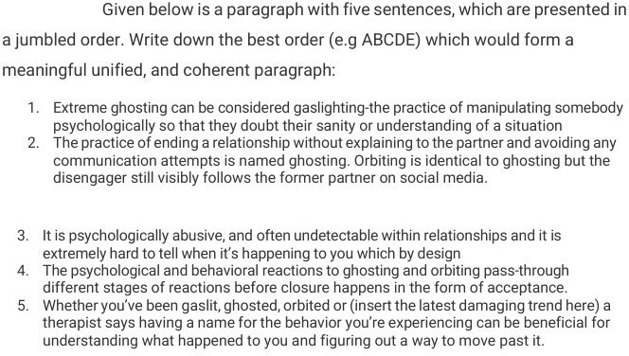
Question 144
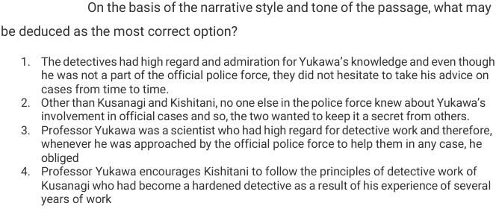

Verbal Ability
Question 145
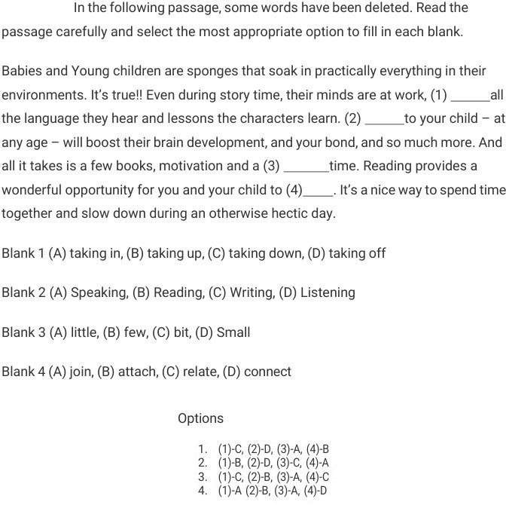

Verbal Ability
Question 146



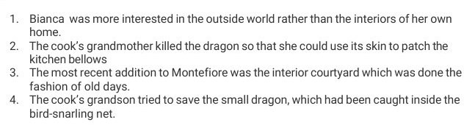

Question 147
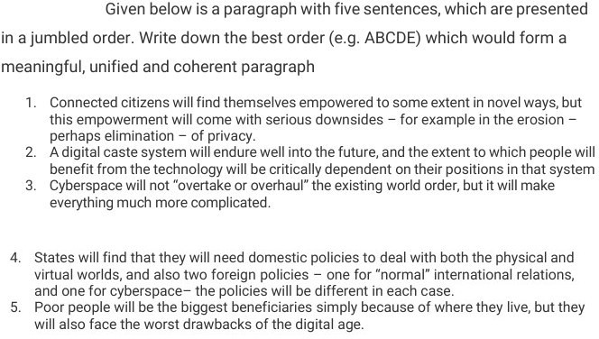

Verbal Ability
Question 148
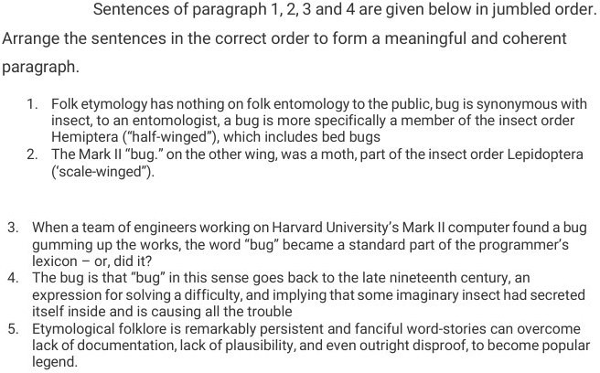

Verbal Ability
Question 149
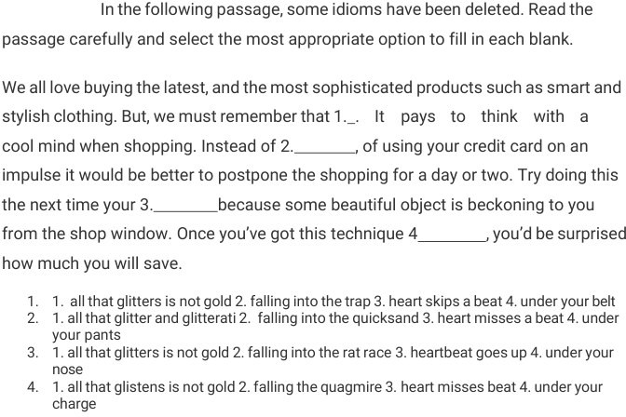

Question 150
